# Amadeus e-Power: How to make Google Analytics work with your e-Power portal

e-Commerce > Amadeus e-Power

https://mye-supportcentre.amadeus.com/eTass/images/average-rating-empty-star-cherry.pnghttps://mye-supportcentre.amadeus.com/eTass/images/average-rating-empty-star-cherry.pnghttps://mye-supportcentre.amadeus.com/eTass/images/average-rating-empty-star-cherry.pnghttps://mye-supportcentre.amadeus.com/eTass/images/average-rating-empty-star-cherry.pnghttps://mye-supportcentre.amadeus.com/eTass/images/average-rating-empty-star-cherry.png

134 view(s)

[Your rating / Your feedback](https://mye-supportcentre.amadeus.com/)

### Solution

* [https://mye-supportcentre.amadeus.com/eTass/images/google-translate-icon.gif](https://mye-supportcentre.amadeus.com/eTass/viewsolution/cas12f6780d1d600/kb-en-GB/googletranslate/popup)
* [https://mye-supportcentre.amadeus.com/eTass/images/google-translate-icon.gif](https://mye-supportcentre.amadeus.com/eTass/viewsolution/cas12f6780d1d600/kb-en-GB/googletranslate/popup)

Amadeus e-Power allows you to enable the service by simply putting the account number in the wizard, and the script will be automatically populated on your website. Here is the procedure:

**1.** Go to your e-Power Portal in Staging or Production and COPY the URL:

Example: <http://www.amadeusepower.com/showroom/Portals/showroom2>

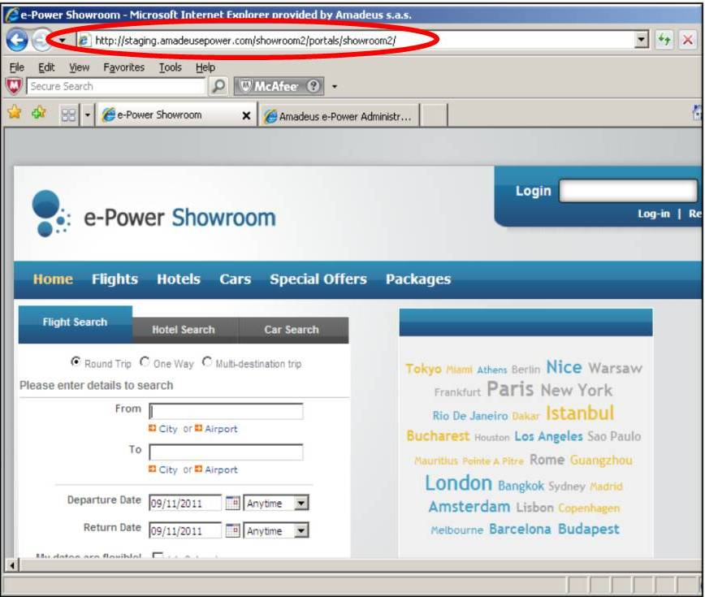

**2.** Go to <http://www.google.com/analytics>

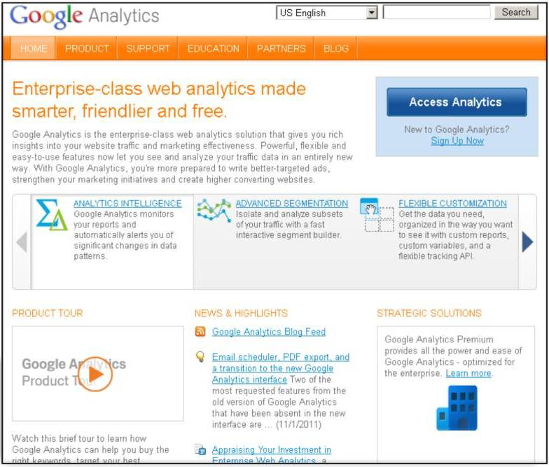

**2.1** Sign-in or create a new account

**2.2** Give some basic information about your e-Power Portal:

* Account Name
* Paste your e-Power Portal URL to "Website's URL": <http://www.amadeusepower.com/showroom/Portals/showroom>

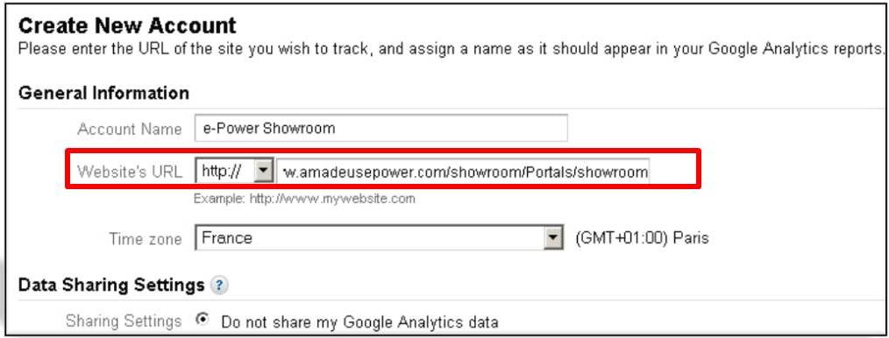

**3.** Google provides you with:

* A unique identifier
* A Tracking code

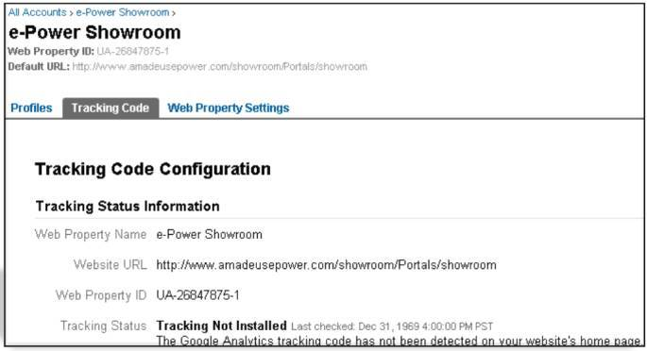

**Note:** Do NOT worry about this Tracking code. You do **NOT** need to copy it on every e-Power page like Google asks. Amadeus e-Power does it for you.

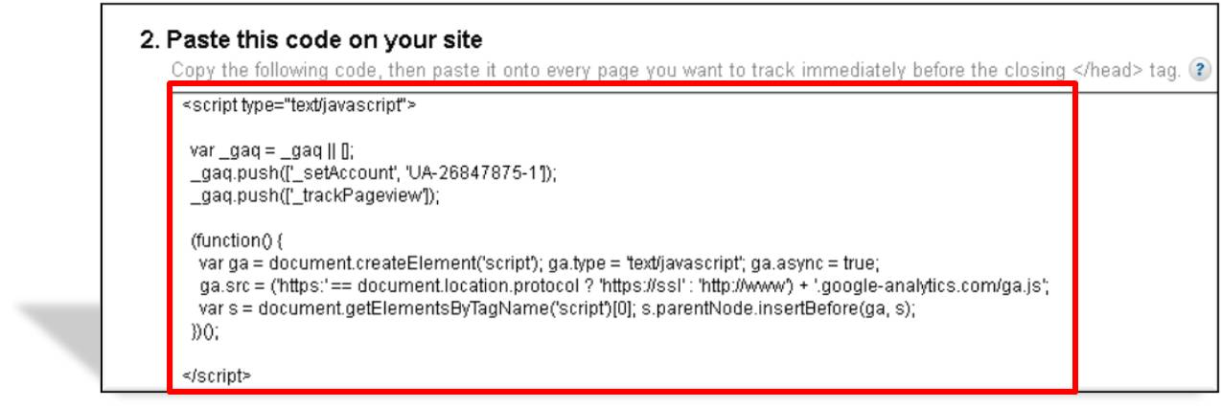

**Just Copy the Unique Identifier called « Web Property ID » https://mye-supportcentre.amadeus.com/eTass/tass/showAttachment.do?askingService=loadImageFile&id=img13417cfeb4900&FileServlet=dummy**

**4.** Go to [admin.amadeusepower.com](http://admin.amadeusepower.com)

**4.1** Sign-In to Staging (Edit Mode)

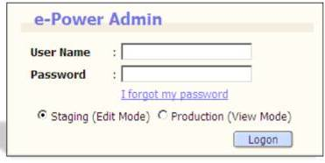

**4.2** Go to Portal > Portal Search: Search and open YOUR Portal

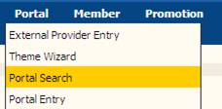

**4.3** Go to "Office Profile Parameters": https://mye-supportcentre.amadeus.com/eTass/tass/showAttachment.do?askingService=loadImageFile&id=img13417d1683800&FileServlet=dummyInsert your Google Analytics’ unique identifier.

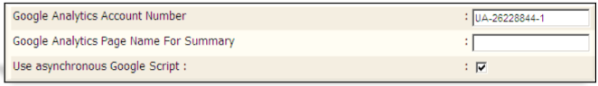

**Note:** For new Google Analytics accounts, tick the « Asynchronous » option

**5.** Click https://mye-supportcentre.amadeus.com/eTass/tass/showAttachment.do?askingService=loadImageFile&id=img13417d1fff500&FileServlet=dummyand "Apply Settings" on Staging

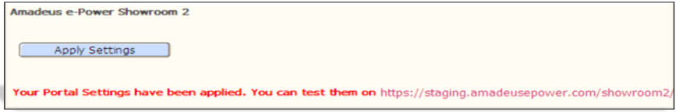

**6.** Wait for Google Analytics’ update.

**Note:** It will take up to 8 hours to update the status from https://mye-supportcentre.amadeus.com/eTass/tass/showAttachment.do?askingService=loadImageFile&id=img13417d309a600&FileServlet=dummy“Tracking not Installed” tohttps://mye-supportcentre.amadeus.com/eTass/tass/showAttachment.do?askingService=loadImageFile&id=img13417d3489700&FileServlet=dummy“Receiving Data”

**7.** Click on "View report" to get your first web analytics.

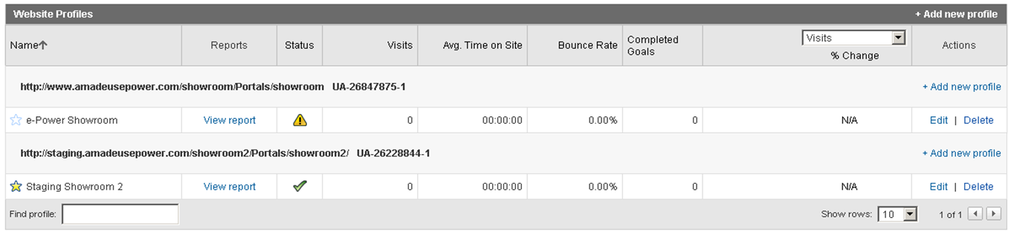

Google Analytics integration - Example:

